Use Case Specification Report

**Use Case Specification**

Untitled1

Revision: 0.2

abril 03, 2019

Approval

|  |
| --- |
| The original of this document is approved and signed by:  Name:  Surname:  Title:  Date:  Signature: |

Revision History

|  |  |  |  |
| --- | --- | --- | --- |
| **Revision** | **Date** | **Description** | **Author** |
| 0.1 | <date 1> | <draft> | <Author name> |
| 0.2 | <date 2> | <release> | <Author name> |

Table of Contents

Microsoft Word users please click here and press F9 to create Table of Contents.

OpenOffice.org users please remove this text and select Insert Table of Content from menu.

Index of Use-Cases

|  |  |
| --- | --- |
| **UseCase** | **Page** |
| Buscar partida | Error! Bookmark not defined. |
| Cambiar apodo | Error! Bookmark not defined. |
| Cambiar foto | Error! Bookmark not defined. |
| Contaco | Error! Bookmark not defined. |
| Crear Cuenta | Error! Bookmark not defined. |
| Crear Partida | Error! Bookmark not defined. |
| Gestion de pjs | Error! Bookmark not defined. |
| Iniciar sesion | Error! Bookmark not defined. |
| Otra info(genero fav etc) | Error! Bookmark not defined. |
| Recuperar contraseña | Error! Bookmark not defined. |
| Unirse a partida | Error! Bookmark not defined. |

# Introduction

## Purpose

<This Document describes Use Case Specification Report.>

## Scope

<This Document intends to describe use case specification for the system.>

## Overview

<Describe what the document contains and explain how the document is organized.>

# Actor Summary

|  |  |
| --- | --- |
| **Primary Actor** | **Use Cases** |
|  | * Recuperar contraseña |
| admin |  |
| Mod |  |
| user | * Buscar partida      * Cambiar apodo      * Cambiar foto      * Contaco      * Crear Partida      * Gestion de pjs      * Otra info(genero fav etc) |
| Visitante | * Crear Cuenta      * Iniciar sesion      * Recuperar contraseña |

# Use Case: Actors1 Diagram

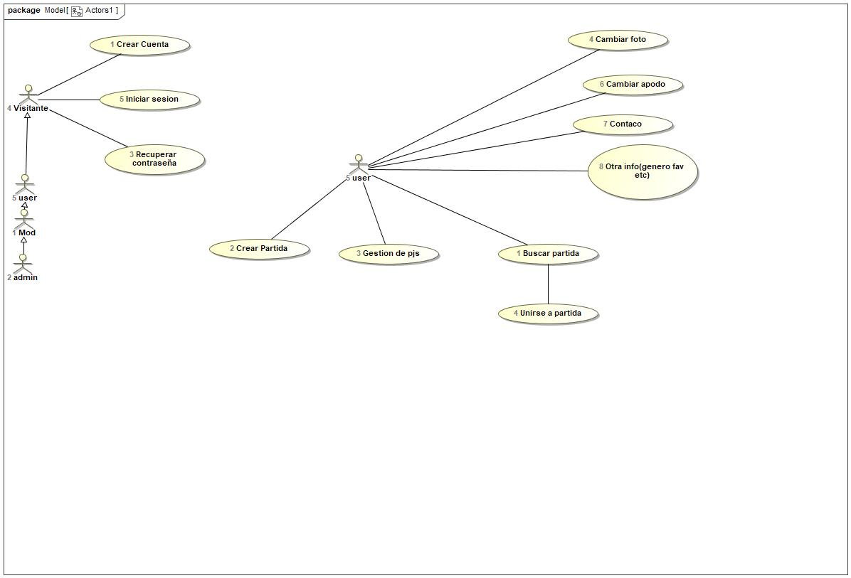

## Buscar partida Use Case

|  |  |  |  |
| --- | --- | --- | --- |
| **Use Case Name** | Buscar partida | ID | 1 |
| **Complexity** | Average Complexity | | |
| **Description** |  | | |
| **Actors** | * user | | |
| **Goal** |  | | |
| **Assumption** |  | | |
| **Non Functional Requirements** |  | | |
| **Pre Condition** | Estar registrado | | |
| **Post Condition** |  | | |
| **Constraints** |  | | |

|  |  |
| --- | --- |
| **Relations** | |
| **Association** | * Unirse a partida UseCase * user Actor |
| **Include** |  |
| **Extend** |  |
| **Generalization** |  |

|  |  |
| --- | --- |
| **Scenarios** | |
| **Basic Flow of Events** |  |
| **Basic Flow of Events Diagrams** |  |
| **Alternative Flow of Events** |  |
| **Alternative Flow of Events Diagrams** |  |
| **Exceptional Flow of Events** |  |
| **Exceptional Flow of Events Diagrams** |  |

## Cambiar apodo Use Case

|  |  |  |  |
| --- | --- | --- | --- |
| **Use Case Name** | Cambiar apodo | ID | 6 |
| **Complexity** | Average Complexity | | |
| **Description** |  | | |
| **Actors** | * user | | |
| **Goal** |  | | |
| **Assumption** |  | | |
| **Non Functional Requirements** |  | | |
| **Pre Condition** |  | | |
| **Post Condition** |  | | |
| **Constraints** |  | | |

|  |  |
| --- | --- |
| **Relations** | |
| **Association** | * user Actor |
| **Include** |  |
| **Extend** |  |
| **Generalization** |  |

|  |  |
| --- | --- |
| **Scenarios** | |
| **Basic Flow of Events** |  |
| **Basic Flow of Events Diagrams** |  |
| **Alternative Flow of Events** |  |
| **Alternative Flow of Events Diagrams** |  |
| **Exceptional Flow of Events** |  |
| **Exceptional Flow of Events Diagrams** |  |

## Cambiar foto Use Case

|  |  |  |  |
| --- | --- | --- | --- |
| **Use Case Name** | Cambiar foto | ID | 4 |
| **Complexity** | Average Complexity | | |
| **Description** |  | | |
| **Actors** | * user | | |
| **Goal** |  | | |
| **Assumption** |  | | |
| **Non Functional Requirements** |  | | |
| **Pre Condition** |  | | |
| **Post Condition** |  | | |
| **Constraints** |  | | |

|  |  |
| --- | --- |
| **Relations** | |
| **Association** | * user Actor |
| **Include** |  |
| **Extend** |  |
| **Generalization** |  |

|  |  |
| --- | --- |
| **Scenarios** | |
| **Basic Flow of Events** |  |
| **Basic Flow of Events Diagrams** |  |
| **Alternative Flow of Events** |  |
| **Alternative Flow of Events Diagrams** |  |
| **Exceptional Flow of Events** |  |
| **Exceptional Flow of Events Diagrams** |  |

## Contaco Use Case

|  |  |  |  |
| --- | --- | --- | --- |
| **Use Case Name** | Contaco | ID | 7 |
| **Complexity** | Average Complexity | | |
| **Description** |  | | |
| **Actors** | * user | | |
| **Goal** |  | | |
| **Assumption** |  | | |
| **Non Functional Requirements** |  | | |
| **Pre Condition** |  | | |
| **Post Condition** |  | | |
| **Constraints** |  | | |

|  |  |
| --- | --- |
| **Relations** | |
| **Association** | * user Actor |
| **Include** |  |
| **Extend** |  |
| **Generalization** |  |

|  |  |
| --- | --- |
| **Scenarios** | |
| **Basic Flow of Events** |  |
| **Basic Flow of Events Diagrams** |  |
| **Alternative Flow of Events** |  |
| **Alternative Flow of Events Diagrams** |  |
| **Exceptional Flow of Events** |  |
| **Exceptional Flow of Events Diagrams** |  |

## Crear Cuenta Use Case

|  |  |  |  |
| --- | --- | --- | --- |
| **Use Case Name** | Crear Cuenta | ID | 1 |
| **Complexity** | Average Complexity | | |
| **Description** |  | | |
| **Actors** | * Visitante | | |
| **Goal** |  | | |
| **Assumption** |  | | |
| **Non Functional Requirements** |  | | |
| **Pre Condition** | Estar en la pagina y usar un correo que no este registrado | | |
| **Post Condition** | Confirmar cuenta | | |
| **Constraints** |  | | |

|  |  |
| --- | --- |
| **Relations** | |
| **Association** | * Visitante Actor |
| **Include** |  |
| **Extend** |  |
| **Generalization** |  |

|  |  |
| --- | --- |
| **Scenarios** | |
| **Basic Flow of Events** |  |
| **Basic Flow of Events Diagrams** |  |
| **Alternative Flow of Events** |  |
| **Alternative Flow of Events Diagrams** |  |
| **Exceptional Flow of Events** |  |
| **Exceptional Flow of Events Diagrams** |  |

## Crear Partida Use Case

|  |  |  |  |
| --- | --- | --- | --- |
| **Use Case Name** | Crear Partida | ID | 2 |
| **Complexity** | Low Complexity | | |
| **Description** |  | | |
| **Actors** | * user | | |
| **Goal** |  | | |
| **Assumption** |  | | |
| **Non Functional Requirements** |  | | |
| **Pre Condition** | Estar logged | | |
| **Post Condition** | Introducir datos necesarios | | |
| **Constraints** |  | | |

|  |  |
| --- | --- |
| **Relations** | |
| **Association** | * user Actor |
| **Include** |  |
| **Extend** |  |
| **Generalization** |  |

|  |  |
| --- | --- |
| **Scenarios** | |
| **Basic Flow of Events** |  |
| **Basic Flow of Events Diagrams** |  |
| **Alternative Flow of Events** |  |
| **Alternative Flow of Events Diagrams** |  |
| **Exceptional Flow of Events** |  |
| **Exceptional Flow of Events Diagrams** |  |

## Gestion de pjs Use Case

|  |  |  |  |
| --- | --- | --- | --- |
| **Use Case Name** | Gestion de pjs | ID | 3 |
| **Complexity** | Average Complexity | | |
| **Description** |  | | |
| **Actors** | * user | | |
| **Goal** |  | | |
| **Assumption** |  | | |
| **Non Functional Requirements** |  | | |
| **Pre Condition** | Tener personajes | | |
| **Post Condition** |  | | |
| **Constraints** |  | | |

|  |  |
| --- | --- |
| **Relations** | |
| **Association** | * user Actor |
| **Include** |  |
| **Extend** |  |
| **Generalization** |  |

|  |  |
| --- | --- |
| **Scenarios** | |
| **Basic Flow of Events** |  |
| **Basic Flow of Events Diagrams** |  |
| **Alternative Flow of Events** |  |
| **Alternative Flow of Events Diagrams** |  |
| **Exceptional Flow of Events** |  |
| **Exceptional Flow of Events Diagrams** |  |

## Iniciar sesion Use Case

|  |  |  |  |
| --- | --- | --- | --- |
| **Use Case Name** | Iniciar sesion | ID | 5 |
| **Complexity** | Average Complexity | | |
| **Description** |  | | |
| **Actors** | * Visitante | | |
| **Goal** |  | | |
| **Assumption** |  | | |
| **Non Functional Requirements** |  | | |
| **Pre Condition** | Haberse registrado en la pagina | | |
| **Post Condition** |  | | |
| **Constraints** |  | | |

|  |  |
| --- | --- |
| **Relations** | |
| **Association** | * Visitante Actor |
| **Include** | * Crear Cuenta UseCase |
| **Extend** |  |
| **Generalization** |  |

|  |  |
| --- | --- |
| **Scenarios** | |
| **Basic Flow of Events** |  |
| **Basic Flow of Events Diagrams** |  |
| **Alternative Flow of Events** |  |
| **Alternative Flow of Events Diagrams** |  |
| **Exceptional Flow of Events** |  |
| **Exceptional Flow of Events Diagrams** |  |

## Otra info(genero fav etc) Use Case

|  |  |  |  |
| --- | --- | --- | --- |
| **Use Case Name** | Otra info(genero fav etc) | ID | 8 |
| **Complexity** | Average Complexity | | |
| **Description** |  | | |
| **Actors** | * user | | |
| **Goal** |  | | |
| **Assumption** |  | | |
| **Non Functional Requirements** |  | | |
| **Pre Condition** |  | | |
| **Post Condition** |  | | |
| **Constraints** |  | | |

|  |  |
| --- | --- |
| **Relations** | |
| **Association** | * user Actor |
| **Include** |  |
| **Extend** |  |
| **Generalization** |  |

|  |  |
| --- | --- |
| **Scenarios** | |
| **Basic Flow of Events** |  |
| **Basic Flow of Events Diagrams** |  |
| **Alternative Flow of Events** |  |
| **Alternative Flow of Events Diagrams** |  |
| **Exceptional Flow of Events** |  |
| **Exceptional Flow of Events Diagrams** |  |

## Recuperar contraseña Use Case

|  |  |  |  |
| --- | --- | --- | --- |
| **Use Case Name** | Recuperar contraseña | ID | 3 |
| **Complexity** | Average Complexity | | |
| **Description** |  | | |
| **Actors** | * Visitante | | |
| **Goal** |  | | |
| **Assumption** |  | | |
| **Non Functional Requirements** |  | | |
| **Pre Condition** | Haber perdido el user o la pass | | |
| **Post Condition** | Consultar correo | | |
| **Constraints** |  | | |

|  |  |
| --- | --- |
| **Relations** | |
| **Association** | * <> Actor * Visitante Actor |
| **Include** |  |
| **Extend** |  |
| **Generalization** |  |

|  |  |
| --- | --- |
| **Scenarios** | |
| **Basic Flow of Events** |  |
| **Basic Flow of Events Diagrams** |  |
| **Alternative Flow of Events** |  |
| **Alternative Flow of Events Diagrams** |  |
| **Exceptional Flow of Events** |  |
| **Exceptional Flow of Events Diagrams** |  |

## Unirse a partida Use Case

|  |  |  |  |
| --- | --- | --- | --- |
| **Use Case Name** | Unirse a partida | ID | 4 |
| **Complexity** | Average Complexity | | |
| **Description** |  | | |
| **Actors** |  | | |
| **Goal** |  | | |
| **Assumption** |  | | |
| **Non Functional Requirements** |  | | |
| **Pre Condition** | Haber buscado la partida deseada | | |
| **Post Condition** | Ser aceptado en la partida | | |
| **Constraints** |  | | |

|  |  |
| --- | --- |
| **Relations** | |
| **Association** | * Buscar partida UseCase |
| **Include** |  |
| **Extend** |  |
| **Generalization** |  |

|  |  |
| --- | --- |
| **Scenarios** | |
| **Basic Flow of Events** |  |
| **Basic Flow of Events Diagrams** |  |
| **Alternative Flow of Events** |  |
| **Alternative Flow of Events Diagrams** |  |
| **Exceptional Flow of Events** |  |
| **Exceptional Flow of Events Diagrams** |  |